For Media Release

3 February 2020

***Inhorgenta 2020***

***Hall A1, Stand 127***

**Introducing two new models to the**

**ORIENT STAR Semi Skeleton collection**

ORIENT STAR announces two new additions to its ORIENT STAR Sports Semi Skeleton collection. Available from March 2020 in marine blue or light silver, the new colourways highlight the semi-skeleton structure, displaying part of the finely-finished movement and distinctive design accents.



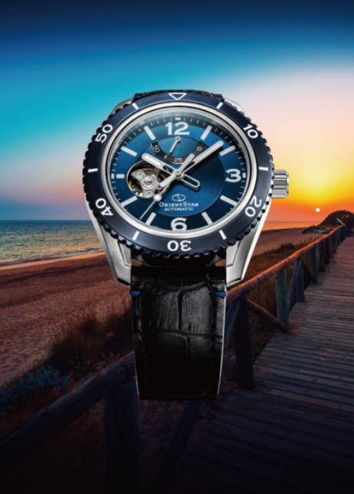

The Semi Skeleton, added to the ORIENT STAR Sports collection in 2019, adopts a screw-down crown and is water resistant to 20 bars. It also has a high-intensity “luminous light” indices and hands making the dial easy to see (except RE-AT01017S), a robust stainless steel case with sharp edges and a rotating bezel surrounding the dial. The popular design has the functionality for outdoor use whilst retaining a distinctive sporty look and feel, making it ideal for every aspect of modern life.

A new addition to the collection features a marine blue dial and bezel, incorporating an energetic design with subtle suggestions of the sea. The refreshing use of colour makes it ideal for any fashion conscious watch fan with their own individual sense of style. The distinctive dial and bezel are complimented by detailed blue stitching, which is offset against the robust black leather strap.

A monotone model is also available, featuring a black bezel and light silver dial reminiscent of clouds floating above the sea. This has black indices and a polished hairline finish on the metal strap.

Both new additions are powered by in-house caliber F6R42. The 46-F6 series automatic in-house movements are known for their excellent winding efficiency, 50-hour power reserve, stable precision and reliability.



**RE-AT0107S 　　　 RE-AT0108L**

**Note to Editors :**

Images are available on request

**About ORIENT STAR**

Established in Japan in 1951, ORIENT STAR originates from a desire to create a mechanical watch that would become a “brightly shining star” in every aspect, from its design and movements to its manufacture and assembly. Drawing on traditional watchmaking skills and the latest in-house integrated design and manufacturing competencies, the brand has continued to create timeless pieces such as the mechanical movements of the 46-F7 series. The delicate details, sophisticated designs and fine intricacies of these high-quality masterpieces attract the attention of watch connoisseurs from all over the world.

Discover more at [orient-watch.com](https://www.orient-watch.com/)

― Product Specifications ―

|  |  |  |
| --- | --- | --- |
| Collection | Sports | |
| Series name | Semi Skeleton | |
| Reference | RE-AT0107S | RE-AT0108L |
| Movement | Automatic (with hand winding) mechanical in-house caliber F6R42 made in Japan | |
| Power reserve | 50 hours | |
| Accuracy | ＋25 seconds ～ －15 seconds per day | |
| Case material | Stainless steel (black plated bezel) | Stainless steel (blue plated bezel) |
| Case size | 43.2mm / thickness 13.7mm | |
| Glass | Front: Sapphire crystal (anti reflective coating), back: crystal glass | |
| Strap | Stainless steel (SUS316L) /  trifold deployant buckle with push button / width 21mm | Leather / trifold deployant buckle with push button / width 21mm |
| Colour of dial | Silver | Blue |
| Other features | Water resistance to 20 bars, power reserve indicator, second hand hacking, 22 jewels, luminescence, uni-directional rotating bezel, see-through exhibition case back | Water resistance to 20 bars, power reserve indicator, second hand hacking, 22 jewels, luminous light, uni-directional rotating bezel, see-through exhibition case back |

ENDS

For more information, product and campaign images and editorial opportunities, please contact:

Epson Europe for ORIENT WATCH Grove Communication

Leonie Toal Chiara Greensill

[leonie.toal@epson.eu](mailto:leonie.toal@epson.eu) [chiara@grovecommunication.com](mailto:chiara@grovecommunication.com)

+44 (0) 1442 227246 +44 (0)2033 756428