ORIENT and ORIENT STAR create watches combining Japanese craftsmanship with timeless design.

Brand History
ORIENT comes from the Latin word ‘Oriri’, meaning to rise.

Established in Japan in 1950, ORIENT is appreciated throughout the world for its reliable and durable timepieces, featuring its own high-quality, in-house designed and manufactured movements.
Emerging in the Post-War era, ORIENT developed a global reputation for its meticulous approach to watchmaking, from traditional mechanical timepieces and quartz movements to creative complications and case designs.
A turning point for ORIENT occurred in the early 1970s when its caliber 46 was introduced. This high-durability movement, praised for its accuracy and reliability, established the brand as a leading light in traditional watchmaking in a time of industrialised production.
Today, ORIENT and ORIENT STAR are chosen by customers in more than 70 countries, including the Middle East, South America, the United States, Asia and Europe.
It has maintained its position at the forefront of mechanical watch production in Japan, focusing on in-house manufactured movements and timeless quality watches for both men and women.

Brand Heritage
For 70 years, ORIENT has created distinctive timepieces with timeless appeal and in-house designed movements.

ORIENT was founded on the principle that quality mechanical watches, created with traditional techniques and experienced craftsmanship, should be accessible to all. Today, this ethos is visible in a broad range of timepieces that place equal importance on style and substance.
ORIENT watches are contemporary and timeless, capturing Moving Moments at work, at home and at play. Minimal, classic case designs are expertly balanced with elegant evening wristwear and sporty designs that value function as well as form.
ORIENT STAR born from a desire to build a mechanical watch that would be a “brightly shining star” in every way, is particularly valued for its semi-skeleton and skeleton watch designs. These design elements are complemented by expert complications, represented by the ever-popular Mechanical Moon Phase and Skeleton.
Now, ORIENT and ORIENT STAR guard the refined principles of its founders by offering timepieces that suit all people, at all stages of their lives.

ORIENT and ORIENT STAR Collections

Both ORIENT and ORIENT STAR reflect decades of watchmaking experience, fused with elegant and timeless design appeal.

ORIENT includes the brand’s core ranges categorised as ORIENT Classic, ORIENT Contemporary, ORIENT Sports, and the new ORIENT Revival, while ORIENT STAR showcases luxury watchmaking innovations and in-house calibers inspired by the brand’s heritage.

ORIENT Classic. ORIENT Contemporary. ORIENT Sports. ORIENT Revival.
Drawing on timeless design codes to suit both men and women, ORIENT offers a broad range of watches infused with traditional and non-traditional details and complications.
One of the highlights for 2020 is the new Revival collection which will include 70th anniversary models such as the King Diver and Retro Future Camera. Other core collections are the elegant Classic, the Sun and Moon, and the Contemporary Small Seconds with Semi-Skeleton.
ORIENT also offers the ORIENT Sports range, including both Japanese Industrial Standard (JIS)-compliant divers’ watches and diver-inspired watches.
For women, the ORIENT Contemporary Ladies Semi-Skeleton and ORIENT Classic Ladies Date are popular choices among the brand’s global customer base.

Discover all ORIENT watches here.

ORIENT STAR Classic. ORIENT STAR Contemporary. ORIENT STAR Sports.

Initially launched in 1951, ORIENT STAR is shorthand for innovation and watchmaking prowess. Traditional design and classic case shapes surround the brand’s own in-house caliber 46-F6 series and 46-F7 movements, designed to ensure a lifetime of reliable and accurate timekeeping.
Having slipped into history, the ORIENT STAR name was formally resurrected in 1997 with a selection of mechanical timepieces inspired by ORIENT heritage. This is perhaps best witnessed in the ORIENT STAR Classic Heritage Gothic, with its distinctive wide font and updated case shape. In 2019, ORIENT STAR launched its new Sports collection, a range of timepieces that deliver form and function in attractive designs suitable for even the most active of lifestyles. The Outdoor range combines style with functionality in a watch that is equally at home in the office as it is in the great outdoors. The new Diver range is a fully-fledged waterproof diver’s watch for 200m air diving (ISO compliant). Finally, the Semi-Skeleton range combines intricate design details with a sporty accent.
Rather than being retrospective, the ORIENT STAR collection of timepieces seeks to capture the best of classic design for more contemporary sensibilities. This careful blend of heritage and modernity allows ORIENT STAR to offer something new and exciting to watch collectors.
ORIENT STAR showcases the brand’s expertise in semi-skeletonised and skeletonised watches, while also offering a range of slimline models and Date, Small Seconds and Mechanical Moon Phase complications. At every turn, it is the attention to detail and beautifully finished movements that give ORIENT STAR timepieces their elegance and flair.
Together, ORIENT STAR Classic, ORIENT STAR Contemporary and ORIENT STAR Sports time pieces are designed to suit every occasion.

Discover all ORIENT STAR watches here.
Watchmaking Innovations

By keeping time the mechanical way, ORIENT and ORIENT STAR have carved their own authentic paths in the history of traditional watchmaking.

ORIENT and ORIENT STAR are proud to be at the forefront of mechanical watch production in Japan.
Every movement is proudly produced in-house, allowing ORIENT and ORIENT STAR to offer a unique product with the highest possible quality, accuracy and reliability. In today’s climate, this focus on in-house production and complete exclusivity is incredibly rare.

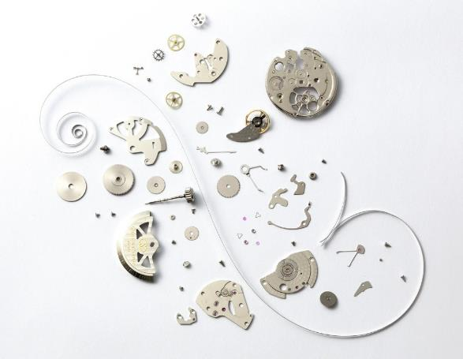

ORIENT traces its story of in-house manufacturing to its ground-breaking automatic caliber 46, introduced in the 1970s. This high-quality and exceptionally durable movement prioritised function over fuss and frills to ensure complete efficiency.
Today, it continues to be used to power many ORIENT and ORIENT STAR watches, while also forming the foundations of additional complication calibers.
Both the caliber 46-F6 and 46-F7 series continue the brand’s long tradition of, and passion for, power reserve indicators, which are present on many ORIENT STAR timepieces.

Discover more at orient-watch.com
ENDS
For more information, product and campaign images and editorial opportunities, please contact:

Epson Europe for ORIENT WATCH
Leonie Toal
leonie.toal@epson.eu
+44 (0) 1442 227246

Grove Communication
Chiara Greensill
chiara@grovecommunication.com
+44 (0)2033 756428

